2. Configure AAA Authentication
Network :
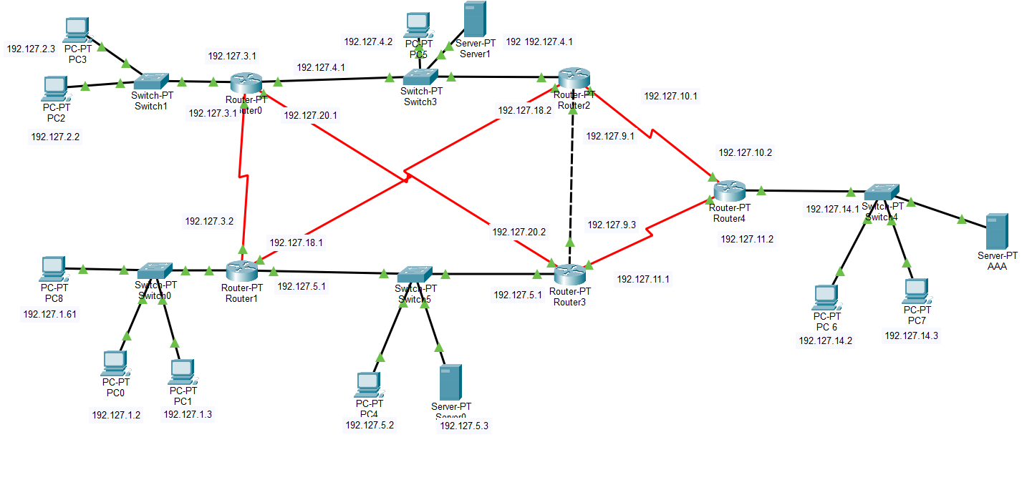
- Tacacs server
- command

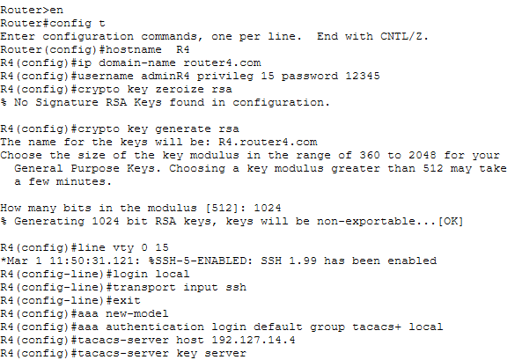
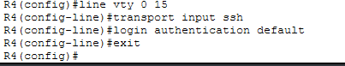

- AAA server Tacacs service
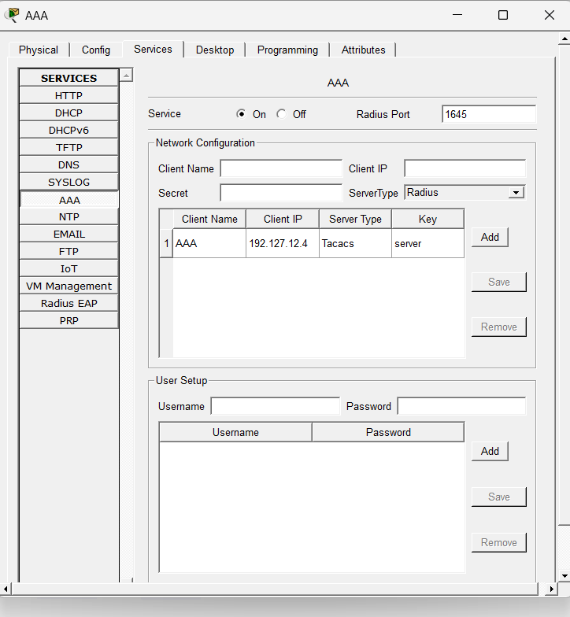

- Access On PC’S
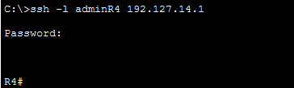

- Radius Server
- command
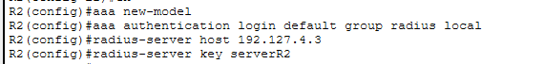
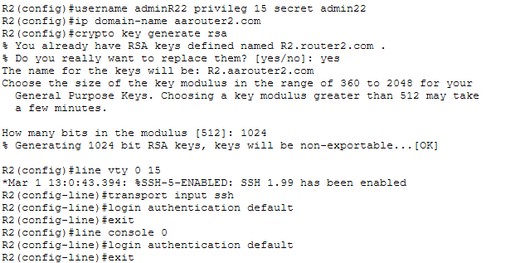

- AAA server Radius Service
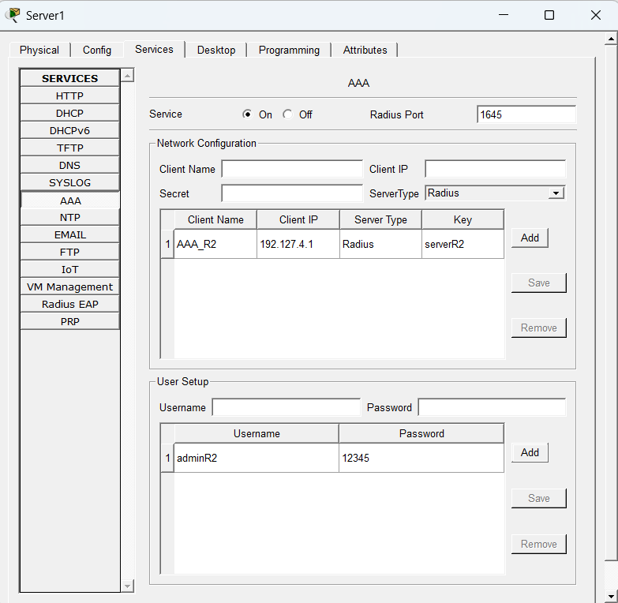
Access On PC’S
